**A**

***PROJECT REPORT***

*On*

***Foodies: Food Delivery System (Partner App)***

*Submitted in partial fulfilment of the requirements for the degree of*

**BACHELOR OF TECHNOLOGY**



Session: - 2024

Submitted by

Palak Agarwal (20ETCCS081)

Pushkar Suthar (20ETCCS094)

Manav Tailor (20ETCCS070)

Bhanupratap Ahir (20ETCCS015)

Jaideep Kumawat (20ETCCS055)

Gagan Jain (20ETCCS039)

Under Guidance of:

Mr. Aaditya Maheshwari

Assistant Professor

Dept. of CSE TINJRIT, Udaipur

**DEPARTMENT OF COMPUTER SCIENCE AND ENGINEERING**

**TECHNO INDIA NJR INSTITUTE OF TECHNOLOGY, UDAIPUR-313001**

**2024**

**A**

***PROJECT REPORT***

*On*

**Foodies: Food Delivery System (Partner App)**

*Submitted in partial fulfilment of the requirements for the degree of*

**BACHELOR OF TECHNOLOGY**



**Session: - 2024**

Submitted by :

Palak Agarwal (20ETCCS081)

Pushkar Suthar (20ETCCS094)

Manav Tailor (20ETCCS070)

Bhanupratap Ahir (20ETCCS015)

Jaideep Kumawat (20ETCCS055)

Gagan Jain (20ETCCS039)

8th Semester (CSE)

Under Guidance of :

Mr. Aaditya Maheshwari

Assistant Professor

Dept. of CSE TINJRIT, Udaipur

**DEPARTMENT OF COMPUTER SCIENCE AND ENGINEERING**

**TECHNO INDIA NJR INSTITUTE OF TECHNOLOGY, UDAIPUR-313001**

**2024**



Department of Computer Science and Engineering

Techno India NJR Institute of Technology, Udaipur-313001

**Certificate**

This is to certify that project work titled **Foodies** by **Palak Agarwal** was successfully carried out in the Department of Computer Science and Engineering, TINJRIT and the report is approved for submission in the partial fulfillment of the requirements for award of degree of Bachelor of Technology in Computer Science and Engineering.

Mr. Aaditya Maheshwari Dr. Rimpy Bishnoi

Assistant Professor Head of Department

Dept. of CSE TINJRIT, Udaipur Dept. of CSE TINJRIT, Udaipur

Date Date



Department of Computer Science and Engineering

Techno India NJR Institute of Technology, Udaipur-313001

**Certificate**

This is to certify that project work titled **Foodies** by **Pushkar Suthar** was successfully carried out in the Department of Computer Science and Engineering, TINJRIT and the report is approved for submission in the partial fulfillment of the requirements for award of degree of Bachelor of Technology in Computer Science and Engineering.

Mr. Aaditya Maheshwari Dr. Rimpy Bishnoi

Assistant Professor Head of Department

Dept. of CSE TINJRIT, Udaipur Dept. of CSE TINJRIT, Udaipur

Date Date



Department of Computer Science and Engineering

Techno India NJR Institute of Technology, Udaipur-313001

**Certificate**

This is to certify that project work titled **Foodies** by **Manav Tailor** was successfully carried out in the Department of Computer Science and Engineering, TINJRIT and the report is approved for submission in the partial fulfillment of the requirements for award of degree of Bachelor of Technology in Computer Science and Engineering.

Mr. Aaditya Maheshwari Dr. Rimpy Bishnoi

Assistant Professor Head of Department

Dept. of CSE TINJRIT, Udaipur Dept. of CSE TINJRIT, Udaipur

Date Date



Department of Computer Science and Engineering

Techno India NJR Institute of Technology, Udaipur-313001

**Certificate**

This is to certify that project work titled **Foodies** by **Bhanupratap Ahir** was successfully carried out in the Department of Computer Science and Engineering, TINJRIT and the report is approved for submission in the partial fulfillment of the requirements for award of degree of Bachelor of Technology in Computer Science and Engineering.

Mr. Aaditya Maheshwari Dr. Rimpy Bishnoi

Assistant Professor Head of Department

Dept. of CSE TINJRIT, Udaipur Dept. of CSE TINJRIT, Udaipur

Date Date



Department of Computer Science and Engineering

Techno India NJR Institute of Technology, Udaipur-313001

**Certificate**

This is to certify that project work titled **Foodies** by **Jaideep Kumawat** was successfully carried out in the Department of Computer Science and Engineering, TINJRIT and the report is approved for submission in the partial fulfillment of the requirements for award of degree of Bachelor of Technology in Computer Science and Engineering.

Mr. Aaditya Maheshwari Dr. Rimpy Bishnoi

Assistant Professor Head of Department

Dept. of CSE TINJRIT, Udaipur Dept. of CSE TINJRIT, Udaipur

Date Date



Department of Computer Science and Engineering

Techno India NJR Institute of Technology, Udaipur-313001

**Certificate**

This is to certify that project work titled **Foodies** by **Gagan Jain** was successfully carried out in the Department of Computer Science and Engineering, TINJRIT and the report is approved for submission in the partial fulfillment of the requirements for award of degree of Bachelor of Technology in Computer Science and Engineering.

Mr. Aaditya Maheshwari Dr. Rimpy Bishnoi

Assistant Professor Head of Department

Dept. of CSE TINJRIT, Udaipur Dept. of CSE TINJRIT, Udaipur

Date Date

**Examiner Certificate**

This is to certify that the following students **Palak Agarwal** of final year B.Tech. (Computer Science and Engineering), was examined for the project work titled

***Foodies: A Food Delivery System (Partner App)***

during the academic year 2023 – 2024 at Techno India NJR Institute of Technology, Udaipur

**Remarks:**

**Date:**

Signature Signature

(**Internal Examiner**) (**External Examiner**)

Name :- Name :-

Designation:- Designation:-

Department: - Department: -

Organization:- Organization:-

**Examiner Certificate**

This is to certify that the following student **Pushkar Suthar** of final year B.Tech. (Computer Science and Engineering), was examined for the project work titled

***Foodies: A Food Delivery System (Partner App)***

During the academic year 2023 – 2024 at Techno India NJR Institute of Technology, Udaipur

**Remarks:**

**Date:**

Signature Signature

(**Internal Examiner**) (**External Examiner**)

Name :- Name :-

Designation:- Designation:-

Department: - Department: -

Organization:- Organization:-

**Examiner Certificate**

This is to certify that the following student **Manav Tailor** of final year B.Tech. (Computer Science and Engineering), was examined for the project work titled

***Foodies: A Food Delivery System (Partner App)***

During the academic year 2023 – 2024 at Techno India NJR Institute of Technology, Udaipur

**Remarks:**

**Date:**

Signature Signature

(**Internal Examiner**) (**External Examiner**)

Name :- Name :-

Designation:- Designation:-

Department: - Department: -

Organization:- Organization:-

**Examiner Certificate**

This is to certify that the following student **Bhanupratap Ahir** of final year B.Tech. (Computer Science and Engineering), was examined for the project work titled

***Foodies: A Food Delivery System (Partner App)***

During the academic year 2023 – 2024 at Techno India NJR Institute of Technology, Udaipur

**Remarks:**

**Date:**

Signature Signature

(**Internal Examiner**) (**External Examiner**)

Name :- Name :-

Designation:- Designation:-

Department: - Department: -

Organization:- Organization:-

**Examiner Certificate**

This is to certify that the following student **Jaideep Kumawat** of final year B.Tech. (Computer Science and Engineering), was examined for the project work titled

***Foodies: A Food Delivery System (Partner App)***

During the academic year 2023 – 2024 at Techno India NJR Institute of Technology, Udaipur

**Remarks:**

**Date:**

Signature Signature

(**Internal Examiner**) (**External Examiner**)

Name :- Name :-

Designation:- Designation:-

Department: - Department: -

Organization:- Organization:-

**Examiner Certificate**

This is to certify that the following student **Gagan Jain** of final year B.Tech. (Computer Science and Engineering), was examined for the project work titled

***Foodies: A Food Delivery System (Partner App)***

During the academic year 2023 – 2024 at Techno India NJR Institute of Technology, Udaipur

**Remarks:**

**Date:**

Signature Signature

(**Internal Examiner**) (**External Examiner**)

Name :- Name :-

Designation:- Designation:-

Department: - Department: -

Organization:- Organization:-

**ACKNOWLEDGMENT**

We take this opportunity to record our sincere thanks to all who helped us to successfully complete this work. Firstly, We are grateful to our **supervisor Mr. Aaditya Maheshwari** for his invaluable guidance and constant encouragement, support and most importantly for giving us the opportunity to carry out this work.

We would like to express our deepest sense of gratitude and humble regards to our **Head of Department Dr. Rimpy Bishnoi** for giving invariable encouragement in our endeavors and providing necessary facility for the same. Also, a sincere thanks to all faculty members of CSE, TINJRIT for their help in the project directly or indirectly.

Finally, we would like to thank my friends for their support and discussions that have proved very valuable for us. We are indebted to our parents for providing constant support, love and encouragement. We thank them for the sacrifices they made so that we could grow up in a learning environment. They have always stood by us in everything we have done, providing constant support, encouragement and love

**Palak Agarwal (20ETCCS081)**

**Pushkar Suthar (20ETCCS094)**

**Manav Tailor (20ETCCS070)**

**Bhanupratap Ahir (20ETCCS015)**

**Jaideep Kumawat (20ETCCS055)**

**Gagan Jain (20ETCCS039)**

DEPARTMENT OF COMPUTER SCIENCE AND ENGINEERING

TECHNO INDIA NJR INSTITUTE OF TECHNOLOGY, UDAIPUR - 313001

**CONTENTS**

|  |  |
| --- | --- |
| **Name of Contents** | **Page no.** |
| Certificate 1 | 3-8 |
| Certificate 2 | 9-14 |
| Acknowledgments | 15 |
| Contents | 16 |
| List of Figures | 17 |
| Chapter 1: Introduction   * 1. Title of Project   2. Objective of the Project   3. Technology Used   4. Technology Advantages and Disadvantages | 18  18  19  20  21 |
| Chapter 2: Implementation  2.1 Step 1: Registration & Login  2.2 Step 2: Orders  2.3 Step 3: Inventory   * 1. Step 4: Menu   2. Step 5: Promotions   3. Step 6: My Info | 22  22  24  26  28  30  30 |
| Conclusion | 32 |
| Future Scope | 33 |
| Code Snapshots | 35 |
| Bibliography | 36 |

**LIST OF FIGURES**

|  |  |
| --- | --- |
| Fig.0 Logo | 18 |
| Fig.1.1 Registration Page | 23 |
| Fig.1.2 Login Page | 24 |
| Fig.2.1 Orders Home Page | 25 |
| Fig.2.2 Order - Detail | 25 |
| Fig.3.1 Inventory Page | 27 |
| Fig.3.2 Add Ingredients | 27 |
| Fig.4.1 Menu Page | 29 |
| Fig.4.2 Add Dish | 29 |
| Fig.6 My Info | 31 |
| Fig.7.1 Code snapshot 1 | 35 |
| Fig.7.2 Code snapshot 2 | 35 |

**CHAPTER 1: INTRODUCTION**

**Name of the project:**

Foodies: Food Delivery System (Partner App)

**Problem Statement:**

The current food delivery landscape lacks an efficient platform for restaurant owners seamlessly handle all there business needs in one place. The restaurant owners right now have to manually handle the inventory separately as well as the existing platforms provides a very complex interface resulting in problems with orders management, expenses tracking, and menu handling. Our platforms solves these problems efficiently by providing a very simple user experience resulting in effortless management of all restaurant needs in one place.



***Fig. 0 : Logo***

**Objective of project:**

The project aims to develop a user-friendly web platform that enables the restaurant owners to easily handle all there operational activities in one place. The system will facilitate registration, profile creation, order management, menu management, inventory management, promotions management. The scope includes a secure login system, real-time notifications about incoming orders, and inventory tracking mechanisms for restaurant owners.

***Objective:***

Enhance food delivery systems by providing restaurant owners with an all-in-one platform to manage all their operational activities in one place for efficient working of the restaurant.

***Scope:***

Redesign and augment existing platforms to incorporate inventory management feature and, better and simpler platform for order tracking and promotion creation. Conduct thorough testing for effectiveness and user-friendliness, with the ultimate goal of creating a more helpful and satisfying restaurant management experience.

**Technology Stack:**

1. **Next.js :**

Next.js is utilized for the front-end development of the "Foodies" food delivery system. It offers server-side rendering, static site generation, and seamless integration with React components, enabling efficient and scalable web application development.

1. **TypeORM:** TypeORM is employed as the ORM (Object-Relational Mapping) framework for database interactions within the "Foodies" system. It facilitates the management of database entities and relationships through TypeScript or JavaScript, enhancing productivity and maintainability.
2. **Tailwind CSS:** Tailwind CSS is chosen for styling and design purposes in the "Foodies" frontend. Its utility-first approach allows rapid UI development by composing custom designs using pre-defined utility classes, resulting in a highly customizable and responsive user interface.
3. **Ant Design:**  Ant Design is a popular UI library for React applications. It provides a set of high-quality React components that follow the principles of the Ant Design language. Ant Design offers a wide range of components such as buttons, forms, layouts, navigation menus, modals, tables, and more, making it suitable for building complex user interfaces.

**5. PostgreSQL with Supabase:** PostgreSQL serves as the primary database solution, complemented by Supabase for additional functionalities and management features. Supabase offers real-time database capabilities, authentication, and APIs, augmenting PostgreSQL with modern development conveniences.

**6. VS Code:** Visual Studio Code is utilized as the primary Integrated Development Environment (IDE) for coding and project management in the "Foodies" development process. Its extensive ecosystem of extensions, built-in Git integration, and efficient code editing features streamline the development workflow.

**Advantages of Tech Stack:**

Next.js's server-side rendering and static site generation capabilities enhance performance and user experience by reducing page load times and improving SEO for the "Foodies" food delivery system.

**Disadvantages of Tech Stack:**

Next.js may introduce complexity during setup and configuration, particularly for developers unfamiliar with its ecosystem, potentially requiring additional time and effort to manage server-side rendering and routing intricacies.

**CHAPTER 2: IMPLIMENTATION**

**Step 1:**

**Registration & Login**

Introducing Foodies: Your Ultimate Restaurant Partner

Welcome to Foodies, your one-stop destination for all things perfect! Foodies isn't just your average partner platform; it's your ultimate restaurant companion, designed to make your operations faster and easier.

Embark on your business journey by registering with Foodies. Our registration process is simple yet comprehensive, ensuring we have all the necessary details to enhance your management experience. Provide us with your restaurant details and food security certificates to create your account. Already a member? No worries! Simply click on the login option to access your account seamlessly.

Once you're logged in, get all the amazing features to grow your business effectively. Our intuitive login page requires only your email ID and password to gain access to Foodies's partner platform.

Join us on this revolutionary adventure of changing the working of restaurants and let Foodies be your trusted companion in your everyday management operations. Get ready to grow your business and reach new heights of profits only with Foodies!!

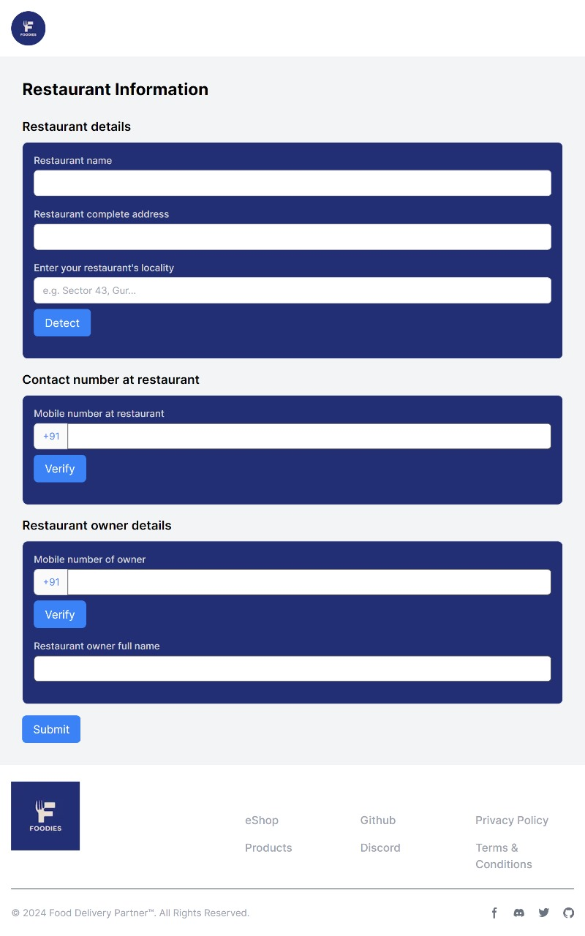

***Fig.1.1 Registration page***

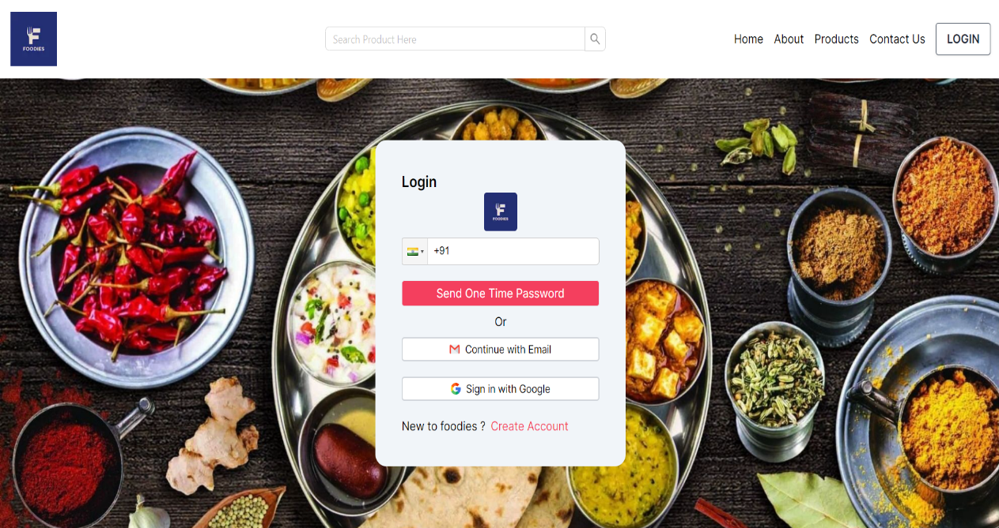

***Fig.1.2 Login Page***

**Step 2:**

**Orders**

The "Orders" page serves as a pivotal component of the website, facilitating efficient order management for restaurant partners. This page offers a comprehensive view of all incoming orders, presenting essential details such as order number, date and time of order, customer information, and current order status. Through intuitive visual cues and clear organization, restaurant staff can easily track the progress of each order in real-time, from receipt to delivery.

Additionally, the "Orders" page provides detailed order information including items ordered, quantities, and special instructions, enabling restaurant partners to prepare orders accurately and efficiently. The "Orders" page plays a crucial role in providing restaurant partners with a robust and user-friendly platform to manage their orders effectively and maximize operational efficiency.

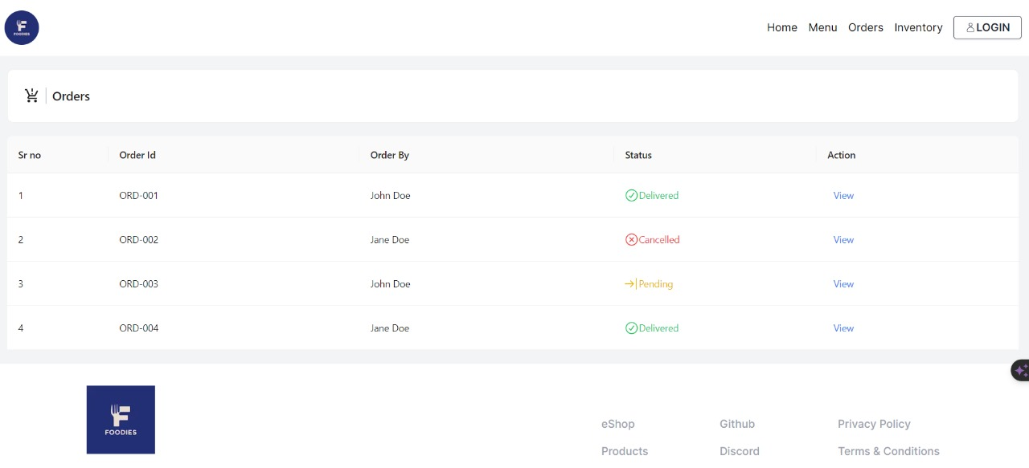

***Fig. 2.1 : Orders Home page***

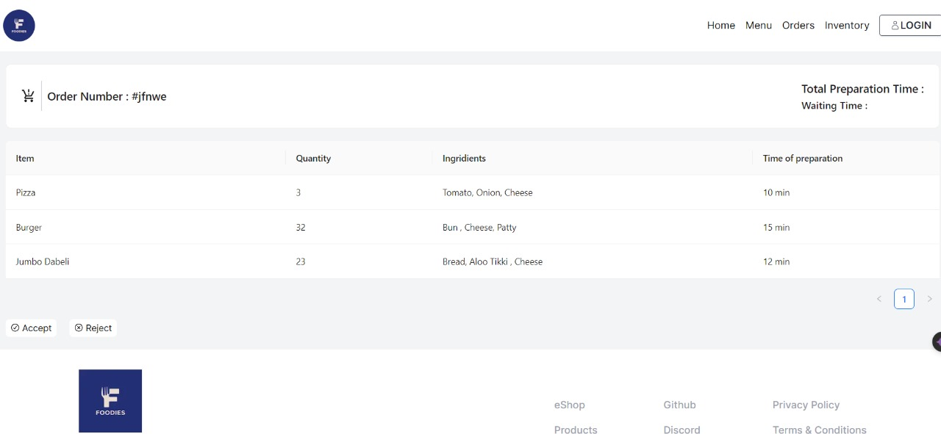

***Fig. 2.2 : Orders - Details***

**Step 3:**

**Inventory**

The "Inventory" page serves as a fundamental component of the website, providing restaurant owners with a centralized platform to manage their inventory of ingredients and track their usage across various dishes. This page offers a comprehensive view of all available ingredients, allowing restaurant owners to list each item along with relevant details such as name, quantity on hand, unit of measurement, and expiration date. Moreover, the "Inventory" page enables restaurant owners to specify which dishes each ingredient is used in, providing valuable insights into recipe formulations and ingredient dependencies.

Through intuitive user interfaces and customizable features, restaurant owners can easily update inventory levels, add new ingredients, or remove items as needed. Additionally, the "Inventory" page may include functionalities such as barcode scanning or bulk importing to streamline inventory management processes and reduce manual data entry efforts.

By associating ingredients with specific dishes, restaurant owners can gain visibility into ingredient usage patterns and make informed decisions regarding menu planning, purchasing, and recipe adjustments. This granular level of detail empowers restaurant owners to optimize their inventory levels, minimize waste, and ensure consistent quality across menu offerings.

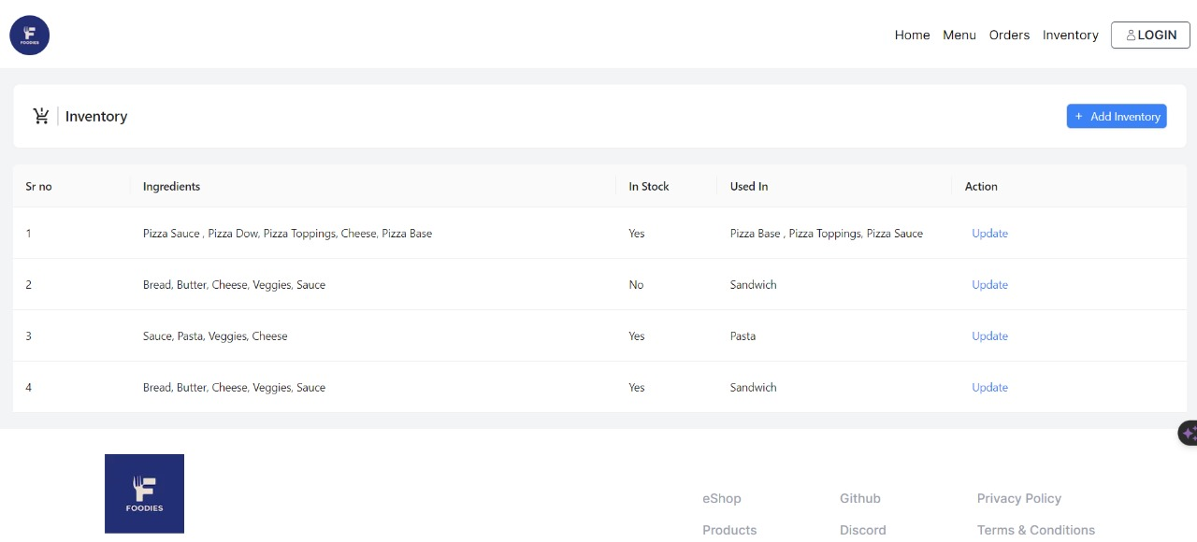

***Fig. 3.1 : Inventory***

**Add ingredient:** This function allows restaurant owners to add new ingredients in their inventory. This opens up a form where all the basic information about the ingredient is added these includes name of the ingredient, in what dishes it is used in and its status can also be defined.

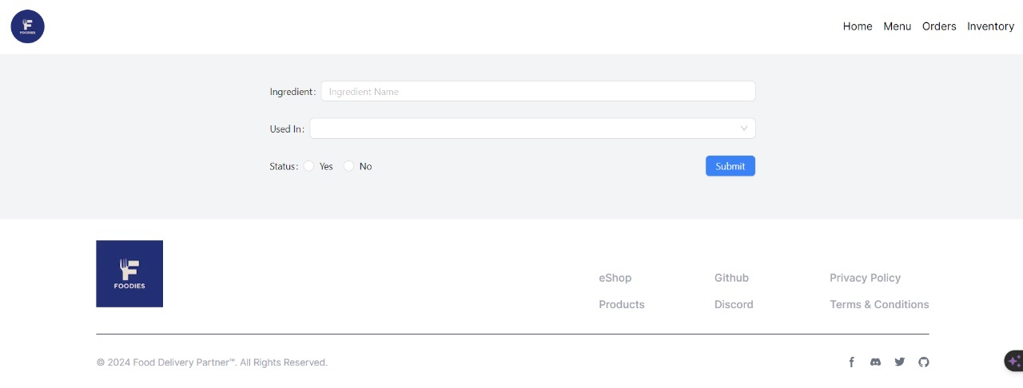

***Fig. 3.2 : Add Ingredient***

**Step 4:**

**Menu**

In the “Menu” page each menu item is displayed alongside its associated image, facilitating visual recognition and enhancing the user experience for restaurant owners. Additionally, the "Menu" page empowers owners to edit and update individual dishes as needed, allowing for adjustments to item descriptions, prices, ingredients, or any other relevant details.

Through intuitive user interfaces and customizable features, restaurant owners can seamlessly navigate the "Menu" page to add new dishes, remove outdated items, or modify existing offerings according to changing preferences or seasonal variations. This flexibility ensures that the menu remains dynamic and responsive to evolving culinary trends and customer preferences.

Integration with other modules such as inventory management facilitates seamless synchronization of menu changes with ingredient availability, ensuring operational efficiency and consistency across the platform. Furthermore, the "Menu" page may offer advanced features such as bulk editing, categorization, or search functionalities to streamline menu management processes and enhance productivity for restaurant owners.

**Add Item:** This function allows restaurant owners to add new dishes in their menu. This opens up a form where all the basic information about the dish is added these includes name of the dish, what ingredients are used in, its image, and its cuisine can also be defined.

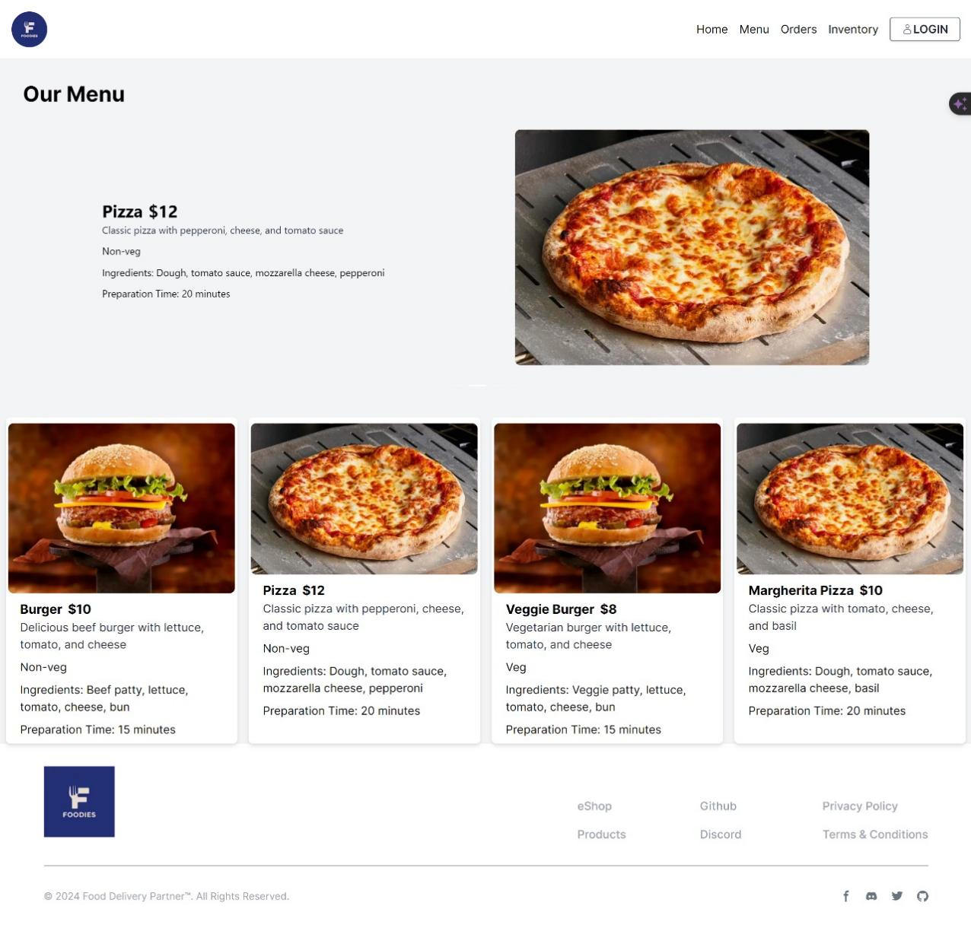***Fig. 4.1: Menu Page***

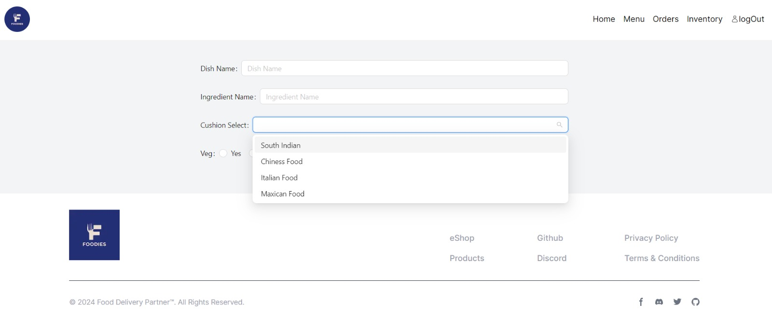

***Fig. 4.2 Add Dish***

**Step 5:**

**Promotions**

The "Promotions" page serves as a strategic tool for restaurant owners to create and manage promotional offers targeted at customers ordering from their establishment. This page provides a user-friendly interface for owners to design, schedule, and track various promotions, thereby enhancing customer engagement and driving sales.

On the "Promotions" page, restaurant owners can create a wide range of promotional offers, including discounts, coupons, bundles, loyalty rewards, and special deals. Owners have the flexibility to customize the details of each promotion, such as the discount amount or percentage, validity period, minimum order requirements, and applicable items or categories.

Owners can also schedule promotions in advance, specifying start and end dates to align with marketing calendars or special events. This scheduling functionality ensures that promotions are launched at optimal times to maximize impact and reach target audiences effectively.

**Step 6:**

**My Info**

The "My Info" page provides a concise overview of essential details about the restaurant for internal reference. This page offers a centralized location for restaurant owners to access key information such as business name, address, contact details, operating hours, and other pertinent details. By consolidating this information in one place, the "My Info" page ensures easy access for restaurant owners to review and update their establishment's details as needed. Additionally, the page may include sections for additional information such as restaurant policies, payment methods accepted, and any unique selling propositions (USPs) to provide a comprehensive snapshot of the restaurant's identity and offerings.

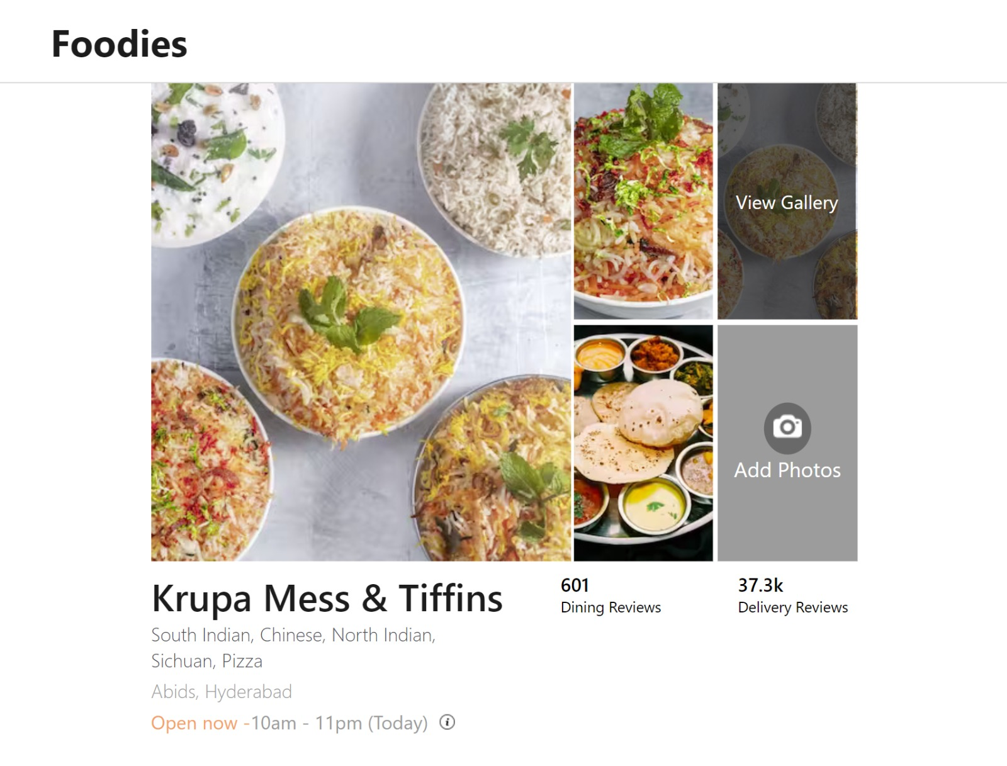

***Fig. 6 : My Info***

**Conclusion:**

The suite of pages - "Orders," "Inventory," "Menu," "Promotions," and "My Info" - collectively offers a comprehensive and integrated platform designed to streamline operations and enhance efficiency for restaurant owners.

The "Orders" page facilitates seamless order management, allowing owners to track incoming orders, update order status, and communicate with delivery drivers or customers in real-time. This functionality ensures smooth order processing and timely delivery, resulting in improved customer satisfaction.

The "Inventory" page empowers owners to manage their ingredient stock efficiently, track usage across dishes, and make data-driven decisions regarding purchasing and menu planning. By providing insights into ingredient availability and usage patterns, this page helps optimize inventory levels, minimize waste, and ensure menu consistency.

The "Menu" page serves as a centralized hub for owners to curate and customize their menu offerings, enabling them to update item details, add new dishes, or remove outdated items with ease. This flexibility ensures that the menu remains dynamic and responsive to changing trends and customer preferences.

The "Promotions" page allows owners to create and manage promotional offers targeted at customers, driving sales and enhancing customer engagement. By offering tools to design, schedule, and track promotions, this page enables owners to execute effective marketing strategies and boost revenue.

Finally, the "My Info" page provides a centralized repository of essential details about the restaurant, offering a convenient reference point for owners to review and update their establishment's information as needed.

Collectively, these pages offer a comprehensive set of tools and functionalities tailored to the specific needs of restaurant owners, allowing them to streamline operations, optimize resources, and drive business growth effectively. By providing a centralized platform for order management, inventory tracking, menu customization, promotional campaigns, and business information management, this suite of pages empowers restaurant owners to run their businesses more efficiently and successfully in today's competitive market.

**Future Scope:**

Looking into the future, integrating customer and delivery partner apps into the system presents a significant opportunity to create a complete and seamless ecosystem that enhances the overall user experience and operational efficiency. By integrating these apps, restaurant owners can offer a cohesive platform where customers can easily place orders, track deliveries, and provide feedback, while delivery partners can efficiently manage their assignments and communicate with customers and restaurant staff.

Integrating customer and delivery partner apps into the system offers several benefits:

1. **Improved Customer Experience**: Customers benefit from a streamlined ordering process, real-time order tracking, and seamless communication with delivery partners. This enhances customer satisfaction and loyalty.
2. **Enhanced Operational Efficiency**: Integrating delivery partner apps allows for better assignment management, optimized delivery routes, and improved coordination between restaurant staff and delivery partners. This leads to faster delivery times and reduced operational costs.
3. **Increased Transparency**: By providing customers with real-time updates on order status and delivery progress, the system fosters transparency and trust, leading to improved customer satisfaction and loyalty.
4. **Data Insights**: Integrating customer and delivery partner apps enables the collection of valuable data on customer preferences, order patterns, delivery performance, and more. Analyzing this data provides insights that can be used to optimize business operations, improve service quality, and drive strategic decision-making.
5. **Personalized Recommendations**: Leveraging data insights, the system can offer personalized recommendations to customers based on their order history, preferences, and behavior. This enhances the customer experience and increases order frequency and value.
6. **Dynamic Pricing**: Using data analytics, the system can implement dynamic pricing strategies based on factors such as demand, time of day, and delivery distance. This helps maximize revenue while remaining competitive in the market.
7. **Enhanced Marketing Opportunities**: Integrating customer and delivery partner apps provides additional channels for marketing and promotional activities. Owners can leverage push notifications, targeted promotions, and loyalty programs to engage customers and drive sales.

In addition to integrating customer and delivery partner apps, the future scope also includes the introduction of additional features such as advanced analytics and insights tools. These tools can provide owners with deeper insights into their business performance, including sales trends, customer demographics, operational efficiency, and more. Armed with these insights, owners can make data-driven decisions to optimize their business operations, improve service quality, and stay ahead of the competition.

**Code Snapshots:**

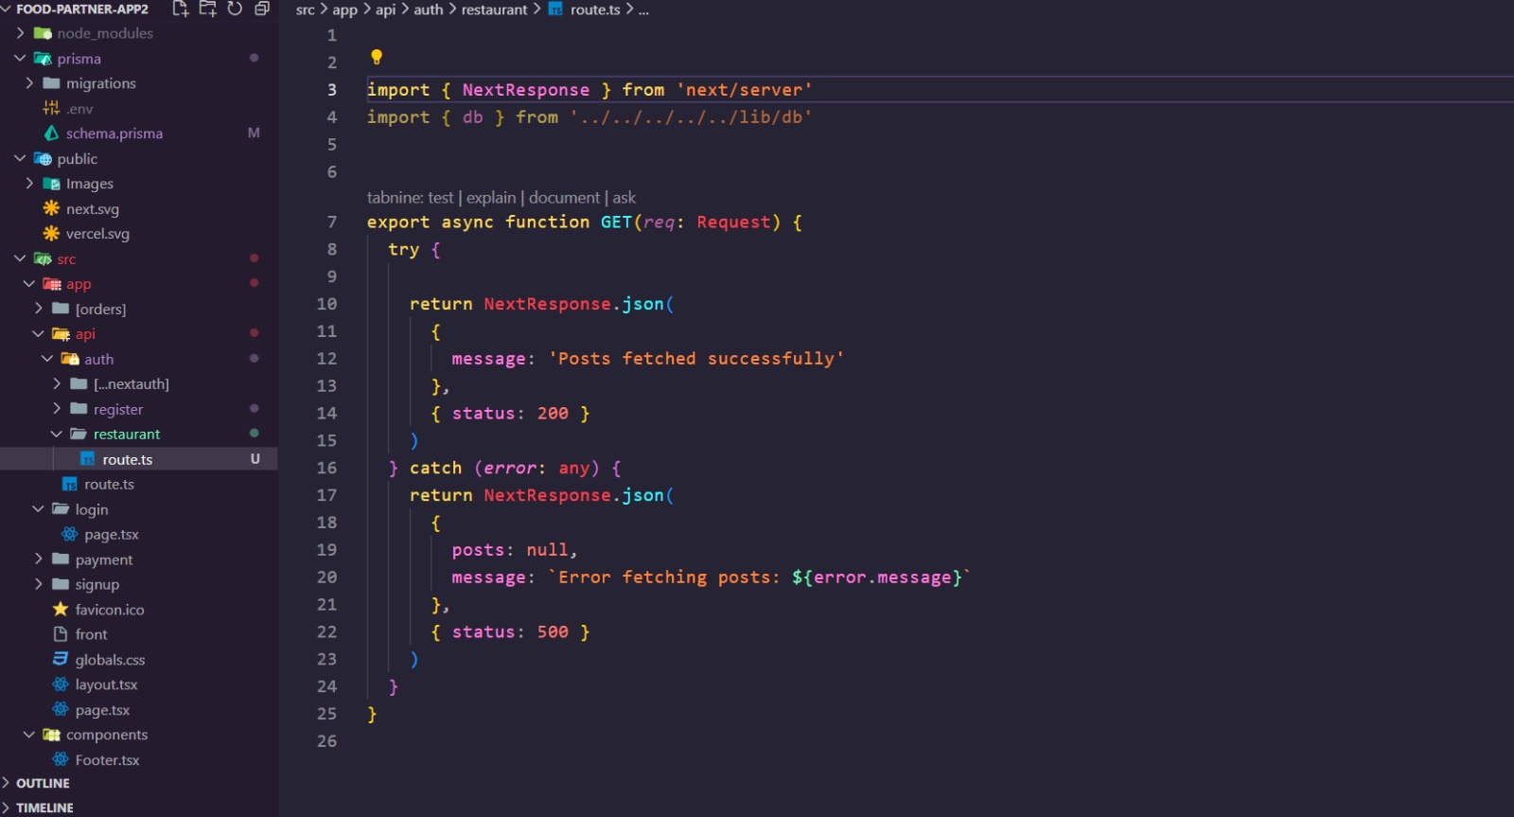

***Fig. 7.1 : Code Snapshot 1***

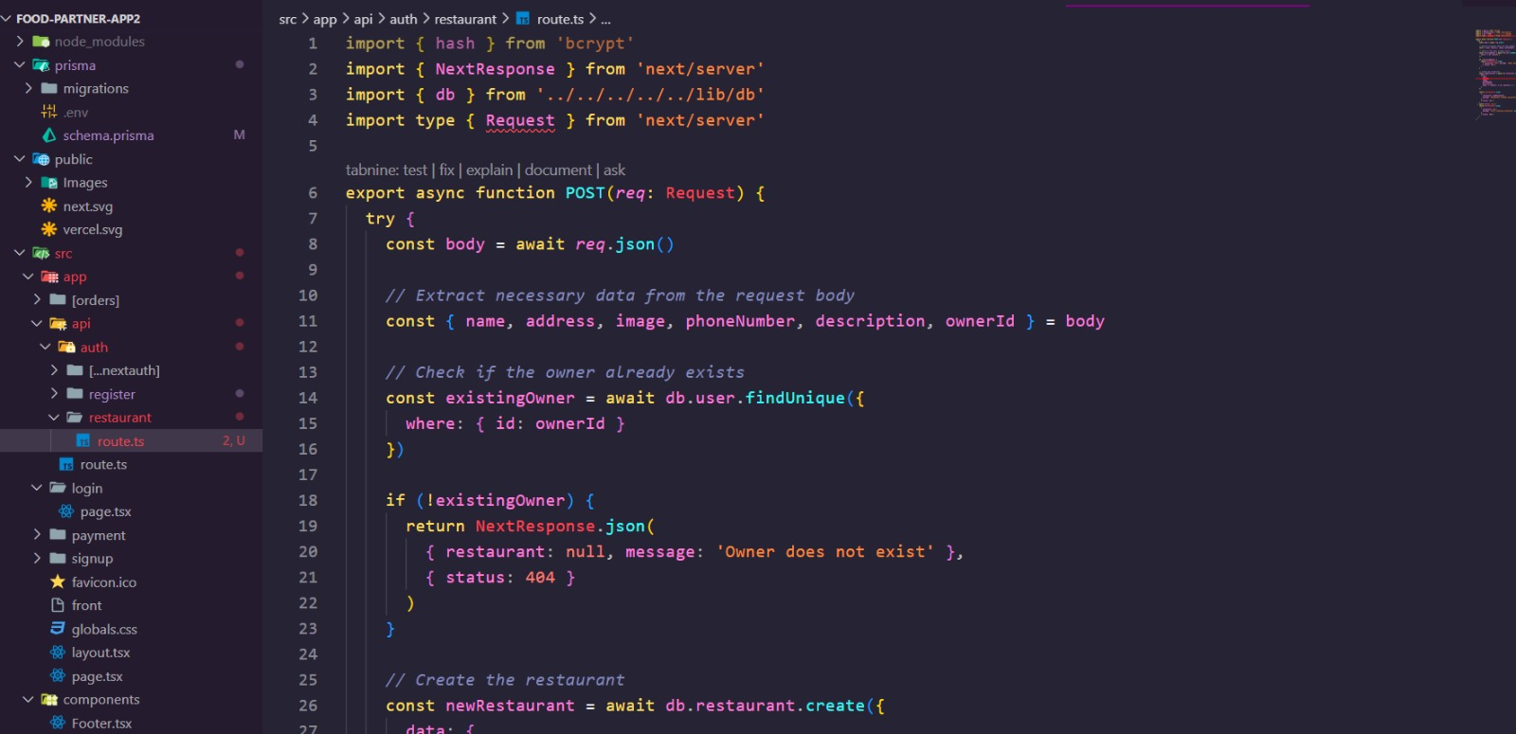

***Fig. 7.2 : Code Snapshots 2***

**BIBLIOGRAPHY:**

1. NextJS: <https://nextjs.org/docs>
2. ReactJS: https://react.dev/
3. TypeORM : <https://typeorm.io/>
4. Tailwind CSS : <https://tailwindcss.com/docs/installation>
5. SupaBase : <https://supabase.com/docs/guides/database/overview>
6. VS Code : <https://code.visualstudio.com/docs>
7. Ant Design : https://ant.design/